PROBLEM_STATEMENT

# TASK3:

In this task you are completely free. <http://testasp.vulnweb.com/>- This is the website. Explore the website and try to find vulnerabilities in the website and report it to us. You will be evaluated on your methods and report you submit.

Don’t worry about evaluation, just report the vulnerabilities as you feel comfortable. Make sure your report matches this >> #751870 Reflected XSS in pubg.com (hackerone.com) You are expected to include the following in the final Report that you have to submit. 1) Proper Steps 2) ScreenShot 3) Video

SOLUTION:

MY REPORT:

Title::- -Cross Site Scripting

Domain::- -Vulneb.com

Sub Domain:: -testasp.vulnweb.com

A basic payload is done on Search box

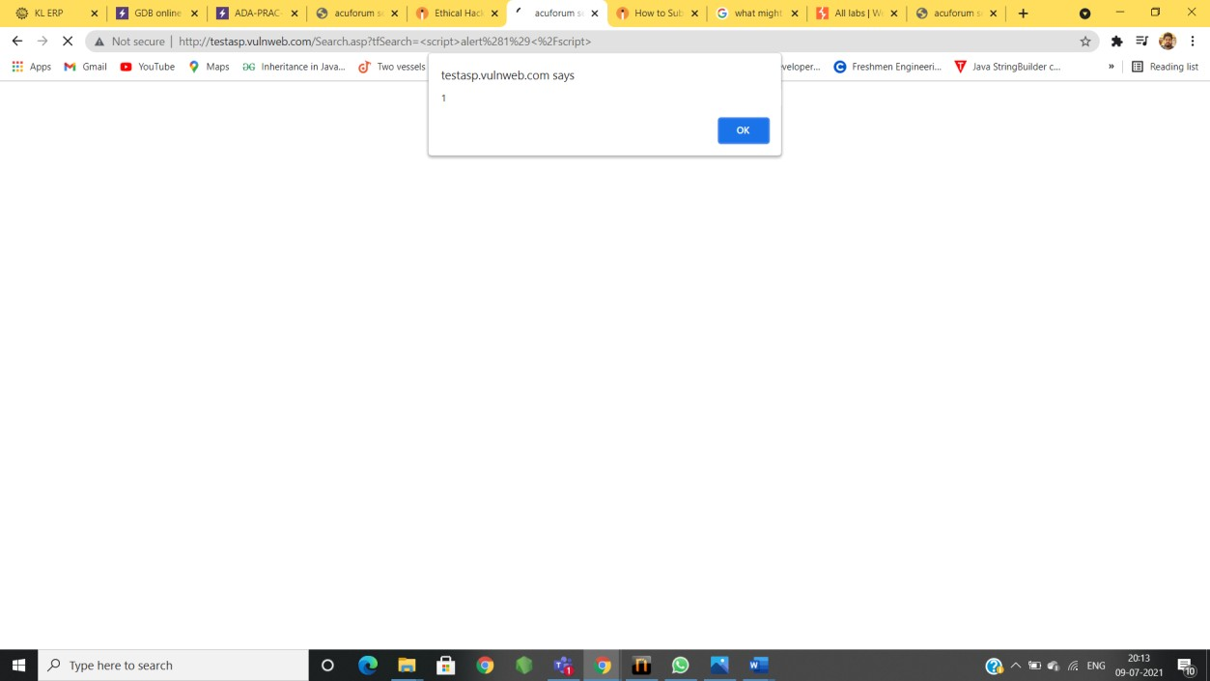

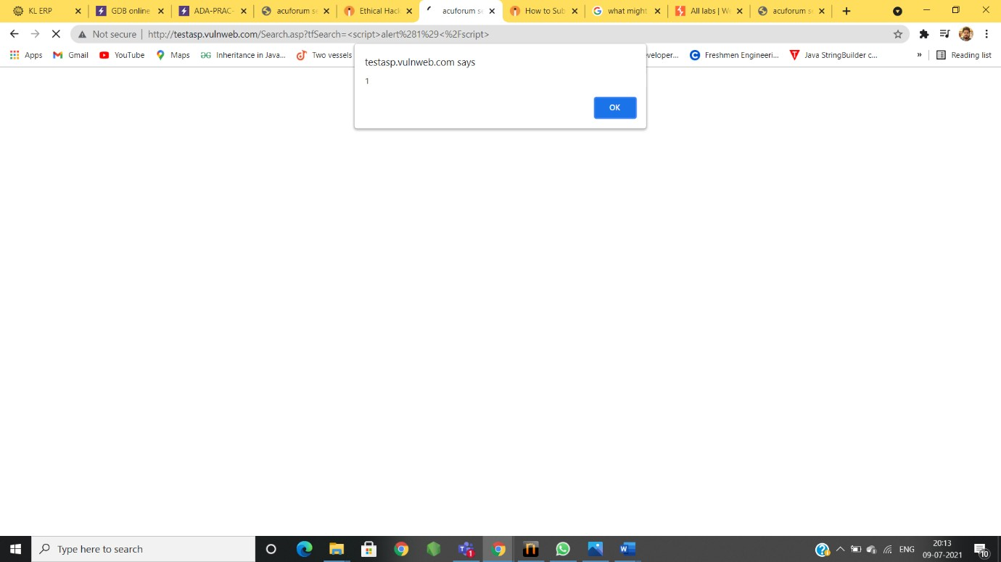

# Vulnerability Information ::

I found cross-site-scripting,which allows an attacker to execute a dynamic script in the context of appilication.

Impact::-

There are many different attacks that can be leveraged through the use of cross-site- scripting .

* →phishing attacks
* →intercepting data and performing man in the middle attack .
* This may lead to the lose of credeintials of this site users because of hackers.

Solution::

This issue occurs because the brower the browser interprets the input as active HTML , javaScript .

So,by removing the script in search dialogue,Vulnerability can be fixed.